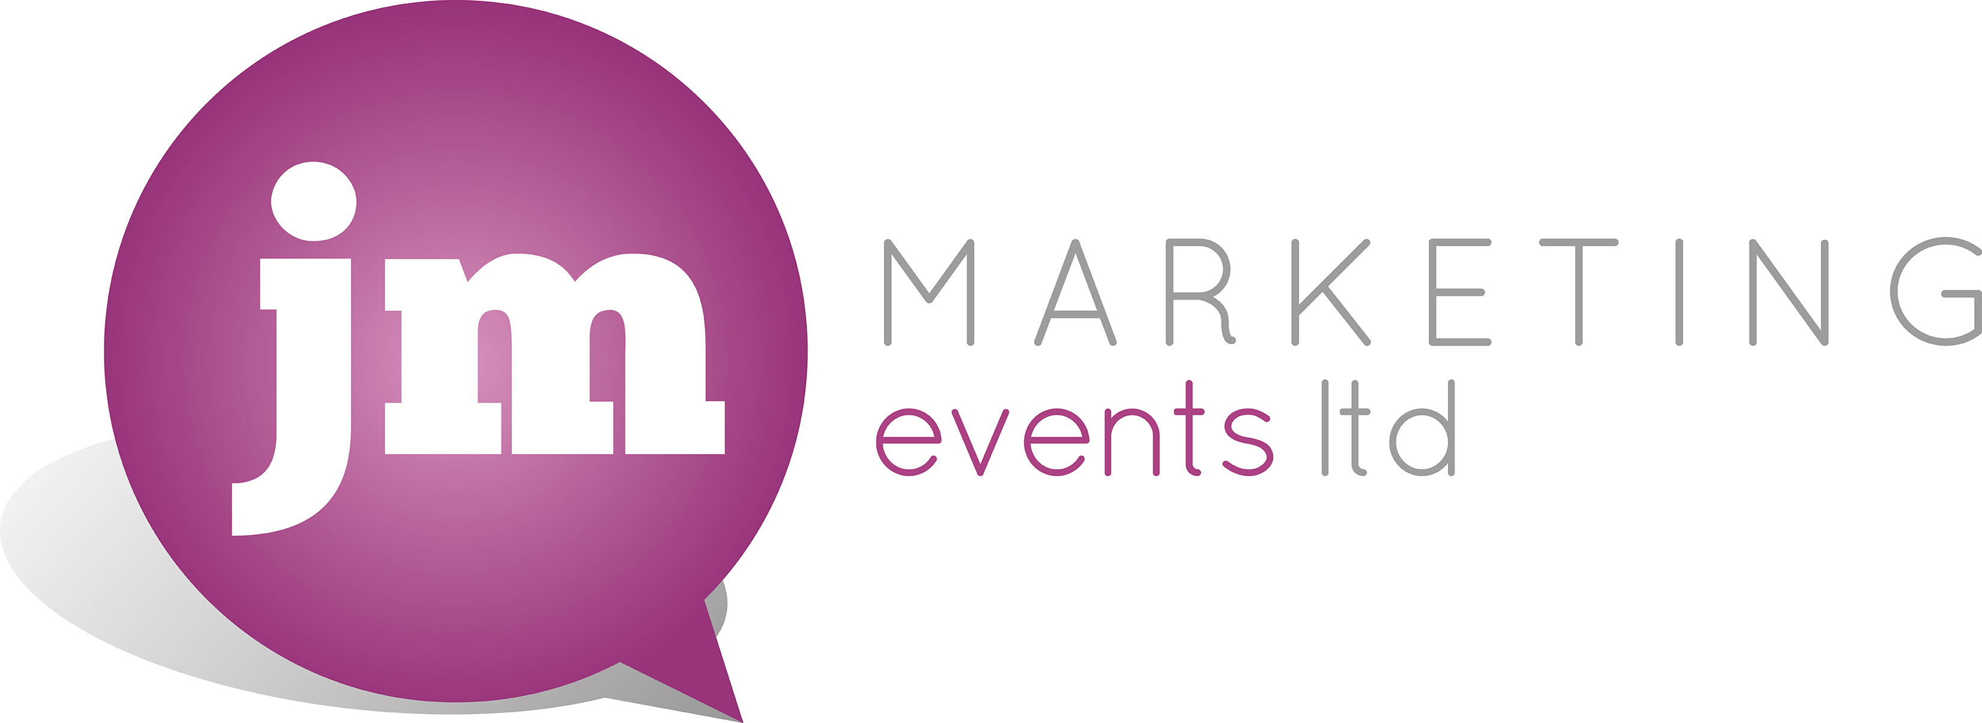

Enquiry Form

The purpose of this enquiry form is to capture the main details about your event, to help us locate the most appropriate venue for your event.

Full contact name

Company name

Contact telephone number

Email address

Type of event e.g. meeting, conference, dinner, teambuilding etc.

Preferred destination

Number of delegates

Date of event

Details of any special requirements for your event

Any other message

Please email your completed enquiry form to janet@jmmarketingevents.com
If you have any questions please contact us on telephone no. +44 (0) 1293 782297 and mobile +44 (0) 7968 308552 or by email. Thank you.

